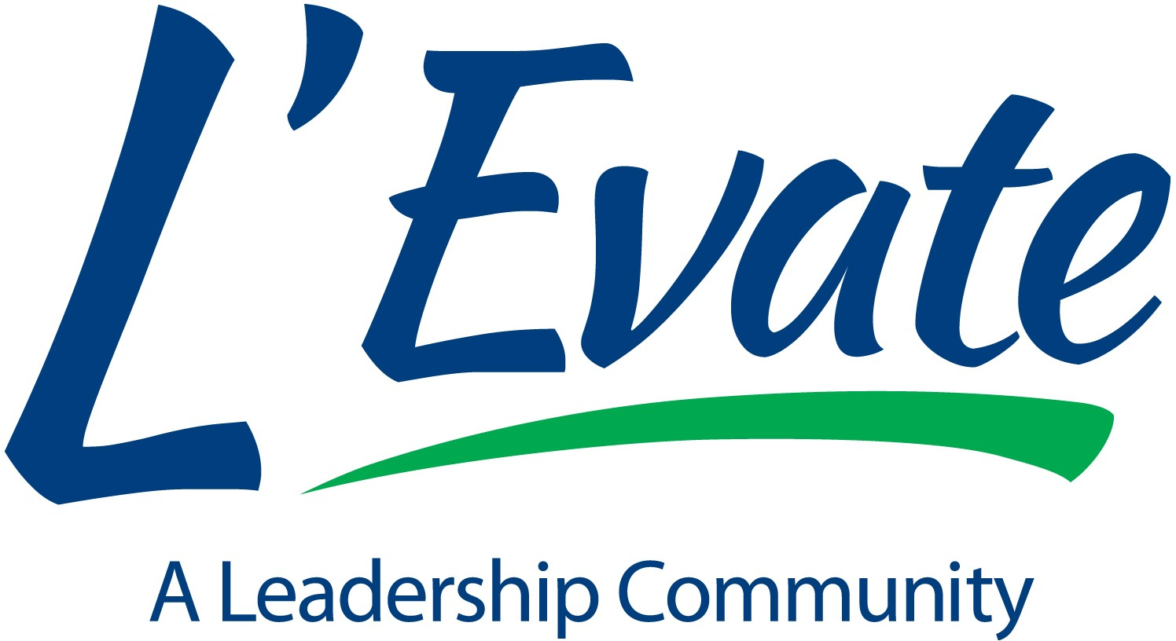

L’Evate is a community-based organization that provides participants with insight into how our community functions, its cultural and organizational differences, and an opportunity to meet and network with other community leaders. Class days include leadership skills, teamwork, and group development training. Topics that impact the community such as wellness, diversity, criminal justice, business development, government, education, sports, and the arts are the focus of the monthly program days. You will experience opportunities that will enrich your life. Leadership is a vital component in the success and economic future of our communities.

The Class of 2025 will begin in August this year. See the schedule on page 2. Selection Qualification Guidelines:
- Selection Committee shall only interview for consideration applicants who:

  - Demonstrate leadership ability or leadership potential and;
  - Live in L’Evate Service area
  - Work in L’Evate Service area
    - Office or place of business in service area or;
    - Office elsewhere, employee main focus of work in service area with strong community presence
  - Final decision on selection of candidates at sole discretion of Selection Committee

L’Evate Service Area is defined by the following: The Eastern boundary is the Wilson County Line from Percy Priest Lake to the Cumberland River. Follow the river around Old Hickory and Pennington Bend toward downtown Nashville. At Fessler’s Lane, cut across to I-24 East to Harding Place and go east to Murfreesboro Road. Turn SE on Murfreesboro Road to Old Murfreesboro Road SE to Smith Springs Road East. Follow Smith Springs Road to Percy Priest Lake. Cross the lake to the starting point of the Wilson County Line. The service area map is the last page of this application.

Applications will be pre-screened for qualifications. Interviews will not be scheduled for candidates who do not meet the criteria.

Our goal is to have a diverse class representative of the service area demographics. L’Evate is a nonpartisan educational organization designed to produce well-informed and motivated community leaders who are willing and capable of working together for a better Community.

The following information will guide you through the process of application and interviews. Thank you for your interest in L’Evate. Please do not hesitate to call Deann Bradford, Executive Director, at 615-414-7427 for further information.

Application deadline is Thursday, March 22, 2024. Please note that you will need about 30 minutes to complete the application. The application does not save your answers if you do not finish and click submit. To complete the application, you will need employment information from the last 5 years and information on where you volunteered, what boards you may have served on. The rest of the application should be things you know.

If you need a fillable PDF application, please reach out to Deann Bradford at 615-414-7427 or deann@levate.org

The 2025 class schedule is listed below. To graduate from the program, participants must commit to attending Orientation and the two-day Opening Retreat in their entirety, which are both mandatory to participate in the 2025 program. In addition, you may miss no more than 10 hours during the 8 program days. Program day times are: 7:30 a.m. – 4:00 p.m.

August 12, 2024 Orientation and Alumni Reception (3:30 p.m. – 7:30 p.m.)
September 10 & 11, 2024 Opening Retreat - Tuesday & Wednesday October 15, 2024 Program Day
November 12, 2024 Program Day
December 3, 2024 Program Day
January 14, 2025 Program Day
February 11, 2025 Program Day
March 11, 2025 Program Day
April 8, 2025 Program Day
May 13, 2025 Program Day
May 22, 2025 Wrap-up (3:30 p.m. – 5:45 p.m.)
May 22, 2025 Graduation (6:00 p.m. – 8:00 p.m.)

In addition to the retreat and program days, participants are expected to participate in volunteering for Field of Honor, and/or the Donelson Christmas Parade (4 or more hours total); participate in additional opportunities for involvement in the community during the class year (a list of examples and suggestions will be provided at Retreat).

The L’Evate Selection Committee will interview candidates and recommend individuals for the class. Candidates selected for interviews will be called to schedule interviews. All candidates will be notified by e-mail of his/her final status by June 12, 2024

Please do not include your check with the completed application. Upon notification of acceptance, the 2025 class fee of $1000.00 will be due and payable to L’Evate. Limited partial scholarships will be available for the 2025 class. Scholarship applications are available on our website levate.org.

Deann Bradford L’Evate
P.O. Box 8387 Hermitage, TN 37076 deann@levate.org Phone: (615) 414-7427 www.levate.org

